Task Description:

Install docker on EC2 and explore the docker commands (docker images, containers, volumes, network)
Techstacks needs to be used :
- AWS EC2
- Docker

EC2 instance:
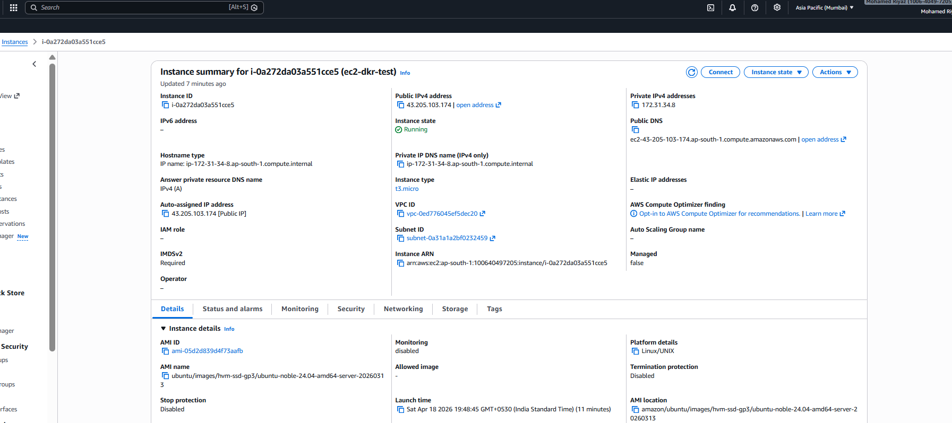
Docker Install:
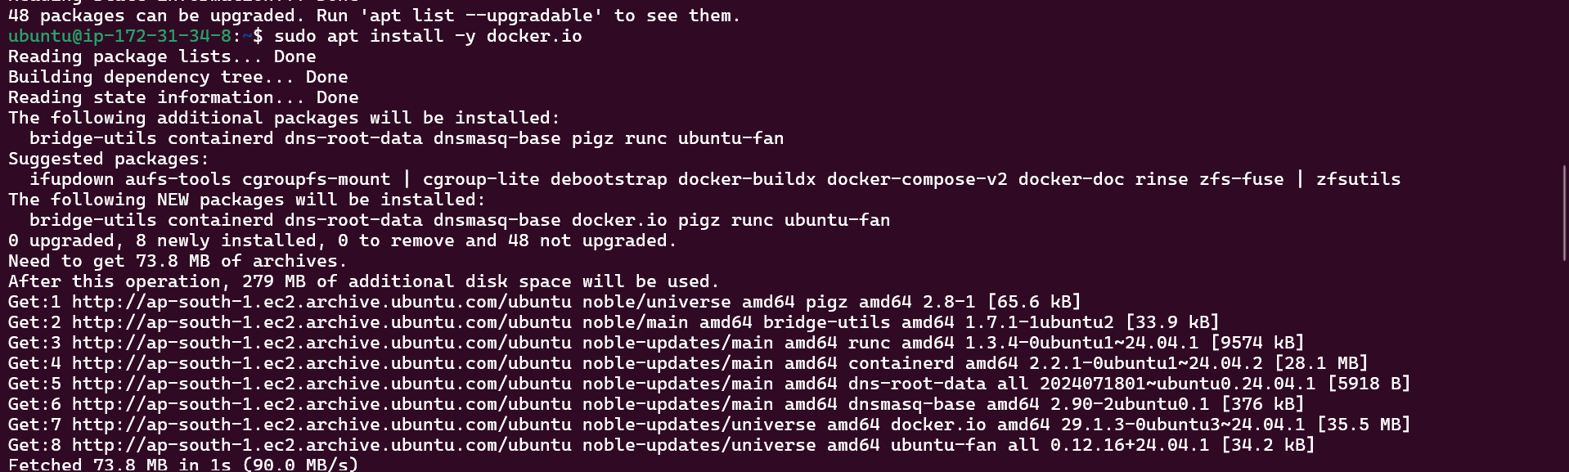
Docker Images:
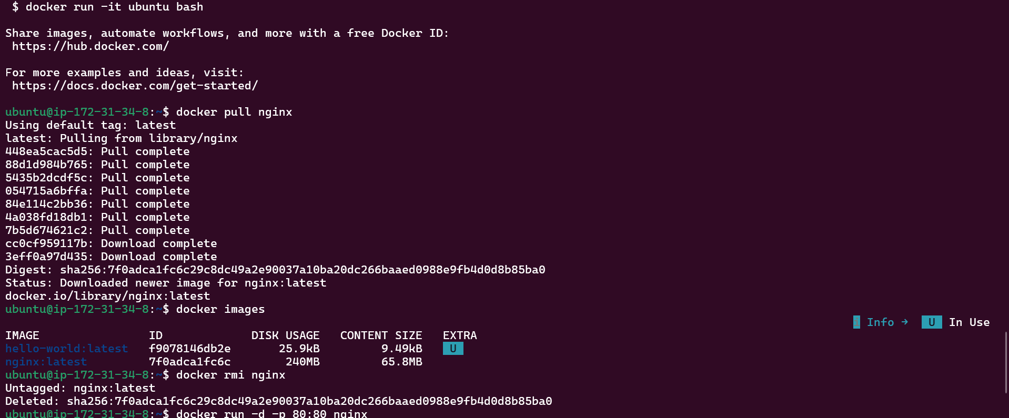
Docker Containers: Inginx:
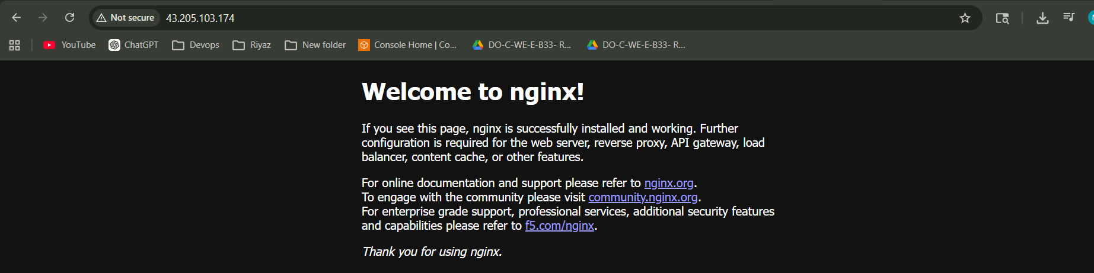
Docker Commands:
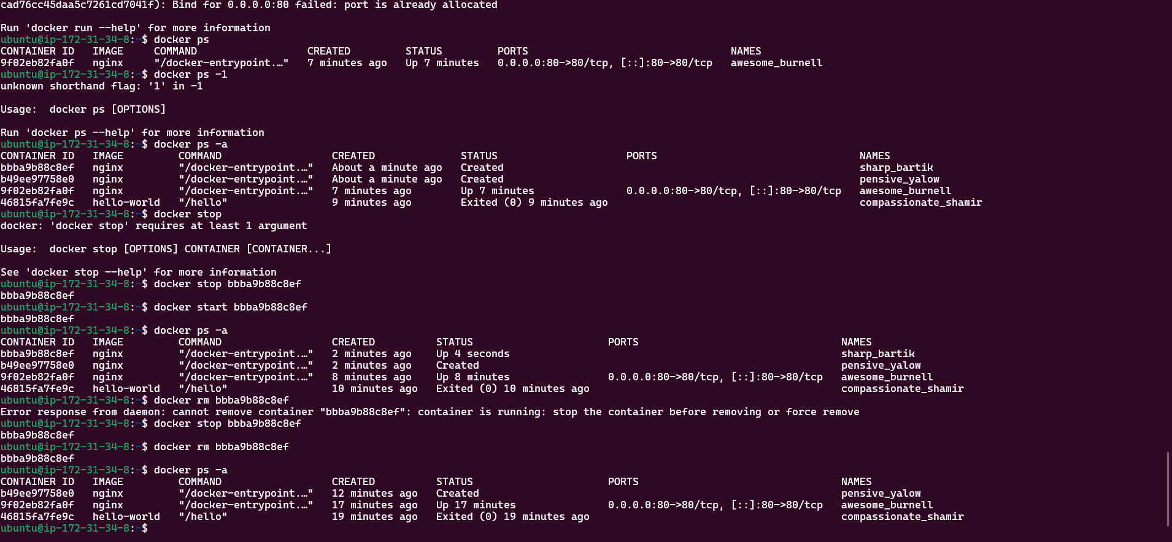
Docker volume:
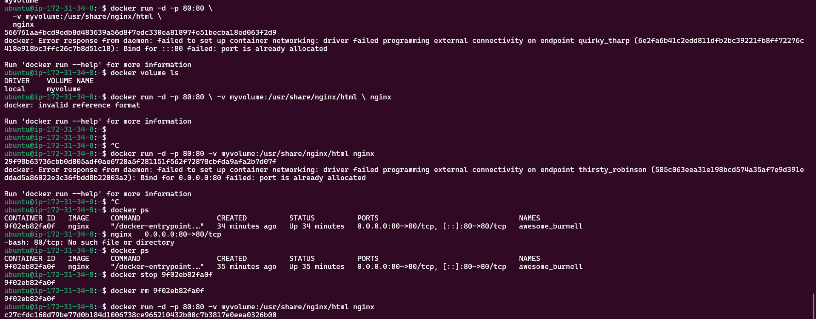
Docker Network:
